MASBO 2022 Fall Professional Development Day

Wednesday, November 23rd, 2022 9:00am -4:30pm
Victoria Inn, Winnipeg

“DISC Advantage and Emotional Intelligence Workshop”
Featuring Al Ruttan

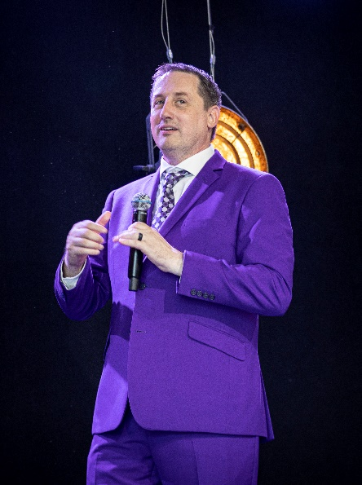 |  | Why do you meet some people and seem to immediately connect with them? In many cases, it is because your personality style is similar to theirs, but what about people with other personality styles? 90% of the stress we experience in relationships is due to not understanding someone else’s personality style. When you are able to identify and understand others better, you are then able to quickly connect with them on a deeper level. Why GUESS and take your chances in relationships when you can know your personality style and the style of those around you? The DISC The DISC Personality Performance Profile assessments and workshops we offer reveal the strengths, potential blind spots, and motivation of your personality style and how to communicate in a way that helps you connect and avoid conflict with others.
The Emotional Quotient Inventory is a fifteen-dimensional model of emotional capacities. For example, one's ability to have strong interpersonal skills is different than their capacity to be intelligently aware of themselves. So, these capacities need to be measured separately. Further, your ability to be intelligently aware of yourself, or self-perception, can be further analyzed into its component parts: self-regard, self-actualization, and emotional self-awareness.
Al Ruttan is a Maxwell Leadership Executive Program Leader, Coach, Teacher and Speaker who desires to help organizations grow their teams, increase productivity, and improve their bottom line. He's taken his passion for leadership and personal growth and now helps leaders, grow themselves and their teams. His business mantra is to unselfishly seek the best or higher good for others.
Register now at https://masbo.inviteright.com/2022fallpd for a very interactive and exciting day of personal and professional growth!

Cost: Members - $275.00 Non-Member - $325.00

